1) How is the aperture distribution of an antenna related to its far-field radiation pattern through the Fourier transformation ?

Consider a one-dimensional aperture having aperture distribution/current density given by I(x) . The far field radiation pattern will be given by the fraunhofer diffraction pattern of the radio waves emitted by the antenna. Since its far-field all the rays are considered parallel to each other while considering the radiation pattern in a direction θ to the normal.

θ

x

The contribution from each element of the aperture dx will be proportional to its current density value given by I(x) dx
The contributions from 2 points on the aperture separated by distance x will be out of phase with each other by x sin( θ). So we need to sum up the contributions from all points on the aperture, which will be I(x) dx multiplied by this phase difference.

This calculation is only for small angles about the normal hence we can use the sin θ ≈ θ approximation. So the net radiation field (F(θ )) in the direction θ will be the following integral-

which is nothing but the fourier tranform of the function I(x). Therefore the far field radiation pattern of an aperture of an antenna is given by the fourier transformation of the aperture current distribution.

2) To understand the mathematical operation of 'convolution' and its properties.
Convolution is an operation between 2 functions whose value shows how much the shape of one function is modified by the other. Each value of the convolution is calculated by first reflecting the second function about the y-axis, shifting the same function by some amount and then calculating the integral of its product with the first function. Mathematically the definition of the convolution of 2 functions f and g, denoted by f * g is -
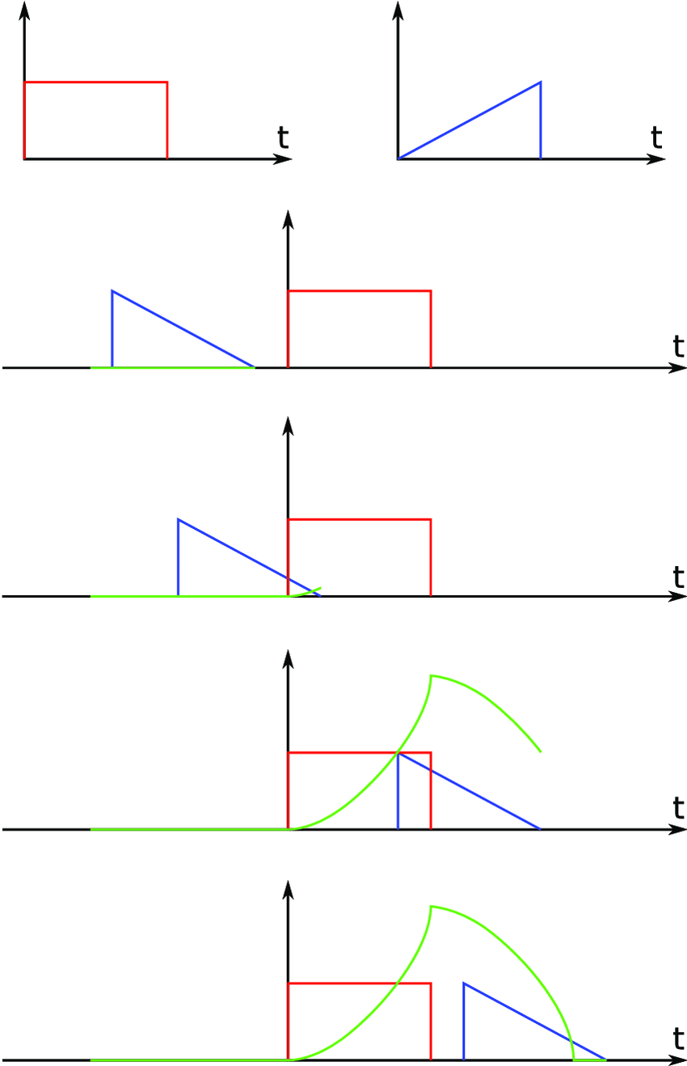

The figure on the right shows an example of convolution.
The red function is f(x) and the blue one is g(x) . The blue curve is first reflected about y-axis then translated by different amounts to give different values of the convolution, given by the green curve.
Image source - Multi-resolution Short-time Fourier Transform Implementation of Directional Audio Coding by Tapani Pihlajamäki

The convolution operator is commutative, ie interchanging f and g doesnt change the result of the operation. One very important property of convolution is given by the convolution theorem which states that the convolution of 2 functions and the product of their respective fourier transforms form a fourier transform pair ie the fourier transform of the convolution of f and g is the product of F and G, where F and G are the fourier transforms of f and g respectively. In other words -

whereshows a fourier transform pair.

3) Explain how a parabolic dish antenna made of wire mesh, like GMRT can still reflect the incoming signals. To what extent can the mesh structure reflect the signal effectively?
Consider a filled-aperture parabolic dish, made of an perfectly conducting metal (ie zero electrical resistance). For a metal body any changes in the electric field outside results in a change in the surface charge density of the metal, which induces an electric field such that the net electric field at each point inside the body is zero. If the electric field outside the body is continuously varied, then this electric field induced by the conductor will keep on varying accordingly.
When a Radio wave hits the metallic dish, the metal similarly induces a varying electric field which propagates forward and we see it as a reflected wave. At the region where which the wave hits the surface, the net field has to be zero. Therefore, the reflected wave propagating from this point has to be at 180º phase difference from the incident wave.
If we replace the solid metal dish with a parabolic dish made up of a mesh of conducting wires, the production of a reflected wave still happens at every point of the metal wires. The changing electric fields of the incident wave, induce a changing a electric field of the metal which propagates as a wave. But since we now have large gaps between the wires in the mesh, some fraction of the incident radiation wont interact with the metal, so they wont excite opposing electromagnetic fields and so pass through the dish. The larger the gaps in the mesh, the greater amounts of energy is lost through transmission. If the wavelength of the incident wave was λ, the transmission loss is acceptably low if the gaps between wires are as low as λ/16.
Apart from the transmission losses due to the gaps in the mesh, further losses in the incident radiation occurs because a real metal body isnt an ideal conductor. Due to some finite resistance, the excited fields produced by the conductor dont completely cancel the incident field which means that the reflected waves are weaker than the incident one.

